What was built:
Two deterministic, evidence-driven sections of the FIDReC Tier-2 submission pack:
- Case overview / executive summary - one narrative paragraph
- Chronology of events - ordered timeline with evidence refs and claimant confirmation prompts
Both are generated server-side and exposed via a single API. There is no frontend UI for this yet - only backend builders + API + CLI test scripts.

Commits: b43fa4b (executive summary v1) → c728b37 (chronology builder)

Architecture overview
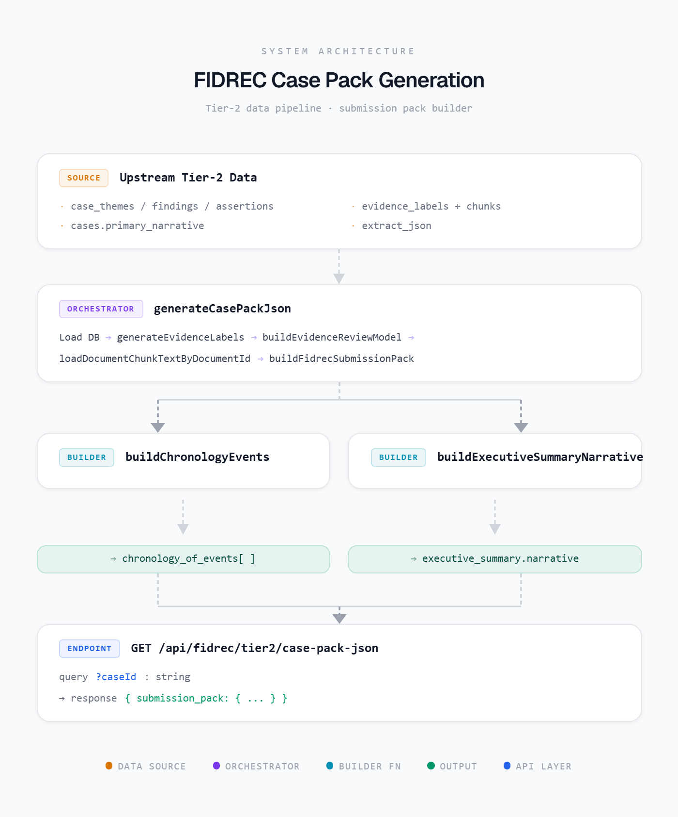
Key design choice: chronology is built first, then passed into the executive summary builder. The overview paragraph does not invent dates - it uses arbitrated facts from documents/narrative.

Prerequisites (upstream pipeline)
The pack generator assumes Tier-2 artefacts already exist for the case:
Layer | File | Role
API | app/api/fidrec/tier2/case-pack-json/route.ts | GET ?caseId=<uuid> -> { submission_pack }
Orchestrator | lib/server/fidrec/generate-case-pack-json.ts | Loads all Tier-2 artefacts, calls builders
Pack assembly | lib/server/fidrec/build-fidrec-submission-pack.ts | Wires chronology → executive summary → full pack
Chronology | lib/server/fidrec/build-chronology-events.ts | New — event timeline from evidence
Executive summary | lib/server/fidrec/build-executive-summary-narrative.ts | Case overview paragraph
Fact arbitration | lib/server/fidrec/arbitrate-executive-summary-critical-facts.ts | Picks claimant name + loss amount from competing sources
Chunk text | lib/server/fidrec/load-document-chunk-text.ts | OCR/extracted text from case_document_chunks

Important data dependency: police report PDF must be registered in case_documents and processed through the evidence pipeline so chunk text contains Date/Time Report Made.

API contract (what frontend consumes today)
GET /api/fidrec/tier2/case-pack-json?caseId=688154e7-...
Response shape (relevant fields only):

{
submission_pack: {
case_id: string
generated_at: string
pack_version: "fidrec_submission_pack_v1"
executive_summary: {
narrative: string // ← case overview paragraph
}
chronology_of_events: ChronologyEvent[] // ← timeline
// ... bank_position, issues_in_dispute, evidence_bundle, etc.
}
}

Types live in:
lib/types/fidrec-chronology.ts — ChronologyEvent
lib/types/fidrec-submission-pack.ts — FidrecSubmissionPack
ChronologyEvent shape
{
event_id: string // e.g. "phishing_email-1"
event_type: ChronologyEventType
event_datetime: string | null // ISO UTC
event_text: string // neutral prose, no liability language
status: "confirmed" | "inferred" | "requires_confirmation"
supporting_evidence: string[] // e.g. ["E5", "E14", "E46"]
claimant_questions: string[] // shown when status = requires_confirmation
}
10 event types: phishing_email, token_registration, limit_change, fraud_transactions, fraud_discovery, hotline_call, police_report, dispute_submission, bank_rejection, technical_access_request

Prerequisites (upstream pipeline)
The pack generator assumes Tier-2 artefacts already exist for the case:
Table / artefact | Used for
case_themes, case_findings | Context + chronology hints
case_bank_assertions, case_assertion_finding_links | Bank position (not overview yet)
case_evidence_requests, case_investigation_questions | Outstanding evidence
cases.primary_narrative, claim_amount | Authoritative claimant/loss facts
case_extract_runs.extract_json | Fallback structured facts
Evidence labels (generateEvidenceLabels) | E1, E2… refs + document typing
case_document_chunks via loadDocumentChunkTextByDocumentId | SMS timestamps, police report date, screenshot filenames

Executive summary - how it works
File: build-executive-summary-narrative.ts + arbitrate-executive-summary-critical-facts.ts
Fact arbitration (priority order)
Claimant name:
- cases.primary_narrative
- Police report
- Statutory declaration
- extract_json
Loss amount:
- primary_narrative
- Police report
- Bank-confirmed loss in correspondence
- cases.claim_amount
- extract_json

Explicit rule: server-computed extract totals must not override an explicit loss stated in narrative/police report/bank correspondence. This is why the rich DBS case shows S$50,109.83 (bank-confirmed) rather than a higher computed total.
Paragraph structure (renderCaseOverviewParagraph)
One paragraph covering:
- Claimant + restitution sought + total loss + scam type + products
- Loss breakdown (deposit vs card) when extractable
- Bank rejection basis (from bank correspondence text — falls back to generic "transactions were authenticated" if no structured assertions)
- Principal issues for FIDReC determination (fixed allowed list)

Diagnostics (not exposed via API today)
generateCasePackJson returns these in internal_debug only:
- executive_summary_case_overview_diagnostics - selected claimant, loss, breakdown, products, rejection basis
- executive_summary_critical_fact_diagnostics - candidate values + selection reasons
Frontend implication: if we want an editable fact-review UI, we need to expose diagnostics via a separate admin/debug endpoint or extend the API response.

Chronology - how it works
File: build-chronology-events.ts (replaces the older document-list approach in build-chronology-of-events.ts)
Design rules
- Events come from evidence content, not uploaded document lists
- Neutral language only — no liability/breach/negligence
- Uncertain facts → status: "requires_confirmation" + claimant_questions
- Police report year anchors undated evidence (screenshots, SMS without year, narrative saying wrong year)
Builder pipeline
- inferCaseYear() — police report date first, else document dates, else corpus year
- Run 10 per-type builders (phishing, token, limit, fraud txns, discovery, hotline, police, dispute, tech access, bank rejection)
- Fold related events to avoid duplication:
  - Token binding on 15 Oct → folded into phishing_email
  - PayNow drain SMSs → folded into limit_change (suppresses standalone fraud_transactions)
  - Fraud discovery → folded into hotline_call (suppresses standalone fraud_discovery)
- Merge duplicates per event_type, sort by datetime
- Assign event_id and evidence refs (E-labels)
Evidence parsing sources
Each builder scans:
- evidenceLabels (type, filename, document_date)
- documentChunkTextById (SMS body, police report fields)
- documentPresentationById (display metadata)
- primaryNarrative + case_findings
Special parsers exist for:
- Phishing screenshot filenames/subjects (Phishing_Email_1.PNG, "Your Digital Token Has Expired")
- DBS SMS patterns (token setup, limit increase, PayNow notifications)
- Hotline call screenshot (Proof to call DBS on 16_10 at 07_19.PNG)
- Police report reference numbers (E/20251016/7004)

Implementation checklist for Lena
Backend (mostly done)
- Chronology builder with event types + folding
- Executive summary with fact arbitration
- GET /api/fidrec/tier2/case-pack-json
- Optional: expose internal_debug diagnostics to admin UI
- Optional: PATCH endpoint to record claimant answers to claimant_questions

Frontend (to build)
- Fetch submission pack on case dashboard
- Executive summary card (narrative paragraph)
- Chronology timeline component with status badges + evidence ref links
- Claimant confirmation UI for requires_confirmation events
- Loading/error states (pack generation can take ~30s — embeddings + evidence review)
Data ops
- Ensure all evidence PDFs/screenshots are in case_documents and processed (evidence_processed_v2 + run_case_extract_v4)
- Tier-2 pipeline run before pack fetch: themes → findings → evidence labels → assertions (when ready)

Key files to read first
- lib/types/fidrec-chronology.ts — event contract
- lib/types/fidrec-submission-pack.ts — full pack contract
- app/api/fidrec/tier2/case-pack-json/route.ts — API
- lib/server/fidrec/build-chronology-events.ts — chronology logic
- lib/server/fidrec/build-executive-summary-narrative.ts — overview logic
- lib/server/fidrec/generate-case-pack-json.ts — data loading orchestration

